CRS 625 Book Review – H. Matthee
Gannett. A. (2018). The creative curve. How to develop the right idea, at the right time. USA: Penguin Random House.
Do you believe it is possible to reduce creativity to a pattern and a code that could be intentionally followed to fully guarantee creative success? In his book, The creative curve. How to develop the right idea at the right time, Allan Gannet, proposes exactly such a formula derived from empirical research studies, neuroscience, and countless interviews with arguably the most successful creatives in their respective industries.
Gannett presents his theory as case studies of individuals and companies and interlace these stories with research findings. As such it is a very easy to read and an engaging book. The stories serve as examples to illustrate his principles while the references to research findings add credibility to his work. To creativity professionals, the first section of the book does not provide new insights, but it strongly reinforces the fact that all people are creative. Gannett applies the universal definition for creativity namely novelty and usefulness as the foundation for his arguments.
Gannett makes a strong case against the ‘aha’ moment of creative brilliance which he calls the ‘inspirational theory of creativity’ and states there is no such thing as a lightbulb moment, rather many subconscious processes that give birth to the inspirational idea. Through his research the author concludes there “is a science and a method to achieving mainstream success, one that anyone can work to master”. The first scientific element Gannett examines is trends. Research pointed to two seemingly contradictory urges revealed in the human psyche; people crave familiarity, yet they seek novelty. It is this trend that led to the concept of the creative curve. According to Gannett all successful creative endeavours follow a bell-shaped curve on the axis of preference and familiarity. Ultimately creative geniuses know what is familiar to their audiences and they use “novelty in ways they know their audience will respond to”, therefore they understand how to balance familiarity with novelty to continuously manage the creative curve.
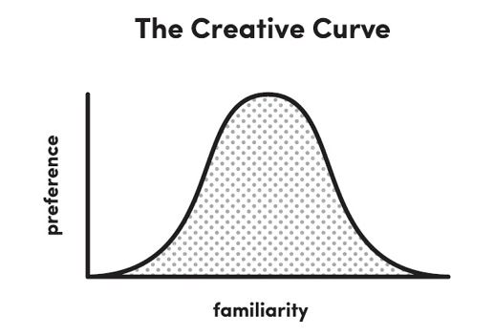
In order to successfully master the creative curve, Gannett identified four laws of the creative curve: Consumption, Imitation, Creative Communities, and Iteration. The basic foundation of consumption is “you can’t have insights about things you don’t know anything about”. This is a very straightforward principle. If you want to excel in a specific domain, you need subject matter knowledge. The more knowledge and experience you have about your discipline, the easier it becomes to identify what ideas are familiar and acceptable to your audience. You are basically building a database of exemplars of success, therefore knowing what type of ideas resonate with your audience. Once you understand what constitutes success to your target audience, you are in a position to add novelty to those ideas.
The second law, imitation, refers to the ability to identify existing patterns and constraints within your field. Gannett argues if you are familiar with the constraints that make an idea successful, you can imitate those patterns which will then allow your brain to focus on the novelty aspect you need to add to make your idea different. Consumption and imitation will give you the right balance on the creative curve to understand how much novelty your audience will be open to, in order to accept your new idea.
According to Gannet, building creative communities are key to “achieving world-class success”. However creative communities do not just consist of any creative collaborators. Instead it requires four types of creatives, a master teacher to share their experience and provide you feedback, a conflicting collaborator who will assist you to overcome your flaws, a modern muse providing not only material but also practical motivation and finally a prominent promoter who will advocate for you as well as your work.
The final law- iteration - consists of the process of conceptualization, reduction, curation, and feedback. This closely resembles the CPS processes of ideation, convergence, and development. Gannett insists on audience feedback before implementation of the product. He also states that the fact that a pattern for creativity exists does not mean it is easy to achieve. In order to achieve success, it requires mastering of the curve which can take many years.
This was a delightful book to read as it looks at creativity from a completely different perspective. The way Gannet made connections between his case studies and scientific research brought the research to life. However, as a scholar in creativity I do have some fundamental issues with key aspects of the book. My first concern is that Gannet uses the terms creativity and innovation interchangeably and as such the book only focuses on Big C creativity. The premise that any person can achieve Big C status by simply following the four laws is problematic as it has not been scientifically proven. Furthermore, with the focus on Big C creativity, I would argue the creative curve is more a roadmap for innovation resulting in entrepreneurship rather than a focus on creativity.
Gannett’s case studies and interviews only focussed on celebrities and big brand companies such as Reddit, The Beatles, Ben and Jerry (ice cream) and J.K. Rowling, with Martine Rothblatt the only one name I didn’t recognise. The book sets the reader up to achieve “world-class success” and whether intentionally or unintentionally, creates the message that those who do not achieve this type of success have failed in their creative endeavours. Another problem with the book is that it heavily focusses on products and with many of the steps and advice, I struggled to apply it to services and processes.
The book promises a ‘how to develop the right idea at the right time’, yet it doesn’t deliver. Instead it relies on the reader to subjectively interpret trends and successes for their specific target audience simply based on enough intentional consumption within their field. There are no guidelines provided to help the reader navigate a plethora of resources and information, neither does it guide the reader on how to find the balance in the creative curve.
Despite these flaws, I thoroughly enjoyed the book and would recommend it to fellow practitioners. The case studies are fascinating and provide insight into the creative processes of those who have been extremely successful, which has made me more mindful of my own creative process. And finally, the seemingly contradictory notion between familiarity and novelty related to the adoption of innovation is an interesting way to explore innovation through the lens of neuroscience.

