Morgan Meheran
CRS 625
Hot Book Blog

Broad Suggestions on How to Foster Creativity in Educational Settings:
A Review of Anne Harris’ Creativity and Education
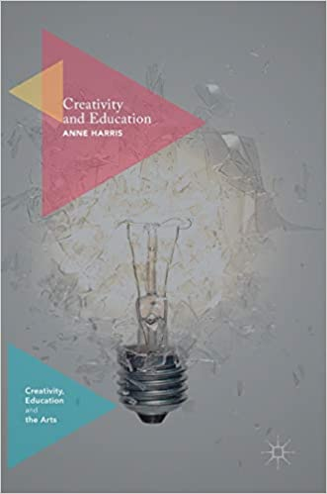
Drawing upon creativity theories and her own research, Anne Harris suggests utilizing Design Thinking as a means to foster creativity in education in her non-fiction book Creativity and Education (Harris, A. (2016). Creativity and Education (1st ed. 2016.). Palgrave Macmillan UK. https://doi.org/10.1057/978-1-137-57224-0). After conducting research on individual traits of creativity and creative environments in Singapore, Canada. the United States and her home country of Australia, for The Harris Creativity Index, Harris narrates ways to promote creative thinking instead of focusing solely on creative doing, specifically within secondary schools. Instead of providing a step by step approach, Harris offers broad suggestions which the reader can tailor to their own school or classroom needs, as “no one model (or assessment, or iteration, or solution) will or should work everywhere and every time.” Taking this approach on the necessity of incorporating creativity throughout all subjects, not just the arts, to best prepare students for occupational success is nothing new; but as Harris explains, few educational institutions across the four countries, have committed to full implementation of teaching for creativity.
The Design Approach of empathizing, defining, ideating, prototyping and testing is the framework for schools to foster creativity within pedagogy, curriculum and all aspects of institutional education, according to Harris. The growing need of globally creativity, has made creativity a commodity and “a core activity of these new global economies”. No longer is creativity only for the gifted or the arts, “creativity itself is universal, and can (and should) be enhanced by all educators.”
Using data from teachers and administrators, within Singapore, Canada, the United States and Australia, common factors that promote or inhibit creativity in school environments are identified. But knowing what these factors are is only the beginning: “once the big picture context is in place, we all must face the task of taking practical steps towards changing thinking, practice and school environments.” The factors that tend to inhibit creativity across all countries, to no surprise were, time constraints, standardization, lack of teacher training, demands of high scores from administration and challenges of available technology. Identified as the top response on where creativity is evident, was unanimously found in collaborative approaches to teaching and learning. Collaboration among teachers and between teachers and students is essential, as teachers are able to model alternative methods on egalitarian ways of creative learning. Harris suggest in order to develop optimal creative environments, teachers should promote students’ cognitive factors, motivation, personality, and social factors, so a safe and comfortable classroom environment can be established. Creativity within the school environment can be developed through teacher training, facilitating cross curricular collaborations, allowing students to lead teaching and learning, develop real-world skills in learning and assessments, having creative partners outside the school community, and keeping student resources readily available. Describing creativity as “unique to the context, cohort and values in which it finds itself”, Harris suggests that the reader adapts and experiments the shared experiences to see what best fits within their own school environment.
As an art educator, who is ever striving to attain more creative learning within my classroom, Creative and Education, outlined a basis on how to achieve this environment. Although the factors identified are generally well known within the creativity and educational fields, the topic remained interesting to see how these issues are evident across different nations. The incorporation of reflections from teachers in Singapore, Canada, the United States and Australia, allowed Harris to create cross cultural, real-world experiences to draw a connection within the global academic field, and the necessity for all educators to emphasize creativity within teaching and learning. The research is clear that creativity is needed for future student success, yet school systems and individual teachers are relucent to transform into creativity forward vessels. Thus, it is up to each of us to further student creative learning, by determining what our students, schools and environments will benefit from the most and begin implementing it immediately.
Providing key points, that teachers and administers have identified as ways to promote creativity within their own school environment, Harris effectively lays out potential steps that can be made towards teaching for creativity, “to encompass forms of teaching intended to develop young people’s own creative thinking or behavior”. Although Harris doesn’t explicitly state how teachers can incorporate collaboration, gain new skills, teach real-world skills or eliminate creative inhibiting factors, she mentions on several occasions that it is up to each individual to determine the most effective way to instill creativity within their specific educational institution. Harris’ Creativity and Education is great for anyone within academia looking for an easy read, that incorporates real-life examples of creativity within schools, to further their knowledge or to discover a starting point on how to implement creativity into your own school environment.

